# **🌍 Voice Translation Web App — User Guide**

## **1. Introduction**

The **Voice Translation Web App** allows you to record your speech, automatically transcribe it, translate it into another language, and play the translated speech aloud. It is designed to make communication across languages easier and faster.

## **2. System Requirements**

* A device with a **microphone** (laptop, PC, or phone).
* A **modern web browser** (Google Chrome, Edge, Firefox, or Safari).
* A stable **internet connection**.
* Access to the **web app link** (provided by the admin).

## **3. Getting Started**

### **Step 1: Open the App**

* Open the app link in your browser.
* You will see the **language selection menus**, recording buttons, transcript and translation boxes.

## **4. Using the App**

### **Step 2: Select Languages**

* In the **“Source Language”** dropdown, choose the language you will speak in.
* In the **“Target Language”** dropdown, choose the language you want your speech translated into.
* 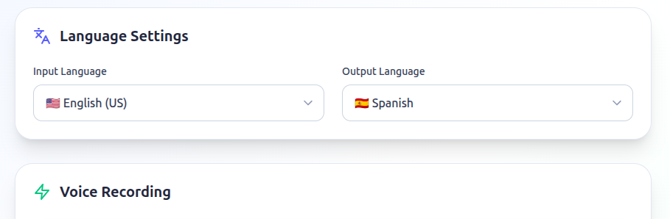

### **Step 3: Record Your Speech**

1. Click the **“Start Recording”** button.
2. Speak clearly into your microphone.
3. When you finish speaking, click **“Stop Recording”**.  
   * (Tip: You can also press the **Enter key** on your keyboard to stop recording quickly.)  
     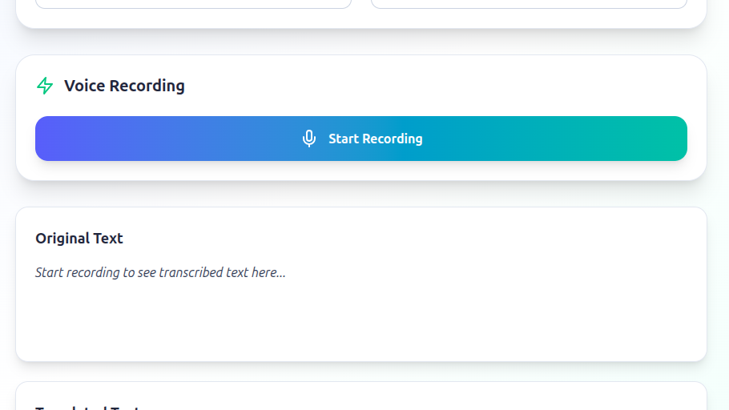

### **Step 4: View Transcription**

* Once recording stops, the app will send your audio to the server.
* Your speech will appear as **text** in the **Transcript** box.

### **Step 5: Translate**

* Click the **“Translate”** button.
* The translated text will appear in the **Translation** box in your chosen target language.

### **Step 6: Listen to Translation**

* Click the **“Play Translation”** button.
* The app will speak the translated text out loud in a natural voice.

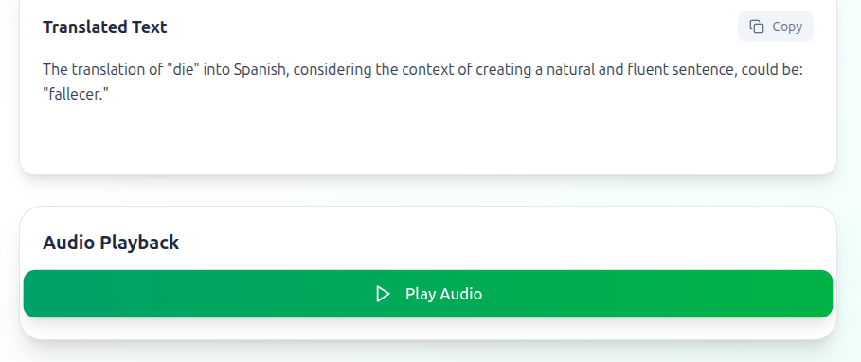

## **5. Example Workflow**

1. Select: **Source Language = English** | **Target Language = French**
2. Click **Start Recording** → say: *“Hello, how are you?”*
3. Transcript shows: *“Hello, how are you?”*
4. Click **Translate** → Translation shows: *“Bonjour, comment allez-vous ?”*
5. Click **Play Translation** → hear French audio playback.

## **6. Troubleshooting**

* **Microphone not working?**
  + Make sure you allowed microphone access in your browser.
* **Got a 422 / Error Message?**
  + Try recording again with clear audio.
  + Ensure you clicked **Stop Recording** before translating.
* **No sound when playing translation?**
  + Check your device volume.
  + Try refreshing the page.

## **7. Tips for Best Results**

* Speak slowly and clearly.
* Use a quiet environment for recording.
* Select the correct source language to improve transcription accuracy.

## **8. Features at a Glance**

✅ Record speech in your language  
 ✅ Automatic transcription  
 ✅ Translation to another language  
 ✅ Text-to-speech playback of translation  
 ✅ Keyboard shortcut (Enter = Stop Recording)

👉 That’s it! You are ready to communicate across languages using the **Voice Translation Web App** 🎉